Track 1: The Analyst
Walmart Predictive Performance Report
Questions 1, 2, 3, 4, 5, 7, 12
Dataset: Walmart Recruiting — Store Sales Forecasting (Kaggle)
45 stores × 81 departments × 143 weeks (Feb 2010 – Oct 2012)
Frameworks: Vertical/Horizontal Analysis, Exponential Smoothing, Visual Hierarchy

Executive Summary for the COO
Walmart's three-year transactional record reveals a textbook margin compression scenario unfolding through 2011, partially recovering in 2012, with a softer holiday season ahead. Four operational findings warrant immediate attention:
- 1. Margin compression is real. Sales declined 3.18% YoY (Feb-Oct 2010 vs 2011) while fuel costs rose 26.14% in the same period. Logistics costs are growing 8× faster than revenue is shrinking.
- 2. Holiday 2012 will likely underperform 2011. The Holt-Winters forecast projects $365M for the 6-week holiday window (95% CI: $358M–$372M), a −9% decline vs the $401M actual in 2011. Inventory orders should be sized to the forecast.
- 3. Promotional spend is concentrated in MarkDown1. MarkDown1 alone consumes 1.16% of revenue — 4× more than MarkDown3 (0.26%). Worth A/B testing rebalancing before committing to next year's promo budget.
- 4. Type A stores have unused footprint potential. Type A stores generate $0.115 per sqft per week; Type C stores generate $0.236 — twice as much. A department-mix transplant from Type C to Type A could yield ~$500K/year incremental revenue with no capex.

Question 1 — YoY Sales vs Operating Cost Comparison

Methodology
Train data spans Feb 2010 to Oct 2012. For a fair YoY comparison we use only months that exist in both years (Feb-Oct), which avoids bias from partial-year overlap. Operating cost is proxied by Fuel_Price from features.csv — fuel is one of the largest controllable costs in retail logistics, and the only cost variable available in this dataset.

Annual sales totals (Feb–Oct alignment)
Year | Total Sales | YoY Change
2010 (Feb–Oct) | $1,797,272,218 | —
2011 (Feb–Oct) | $1,740,102,472 | −3.18%
2012 (Feb–Oct) | $1,785,152,780 | +2.59%

YoY by store type (2010 vs 2011)
Store Type | 2010 Sales | 2011 Sales | YoY %
A (largest) | $1,151,529,000 | $1,124,144,000 | −2.38%
B (mid-size) | $536,863,300 | $510,018,800 | −5.00%
C (smallest) | $108,879,500 | $105,939,800 | −2.70%

Operating cost proxy: average fuel price by year
Year | Avg Fuel Price | YoY Change
2010 | $2.824 | —
2011 | $3.562 | +26.14%
2012 | $3.672 | +3.09%
Solvency Implication — Margin Compression
Sales declined 3.18% while fuel costs rose 26.14% in the same period. This is a classic margin compression scenario. If unchecked, free cash flow erodes meaningfully — reducing the firm's ability to service debt and fund capex. The board should commission a logistics route optimization and supplier renegotiation review within the current quarter. Type B stores were the worst hit (−5.00%) and warrant a separate diagnostic.

Question 2 — Common-Size Analysis: MarkDown Spend as % of Sales

Approach
Treat MarkDown1–MarkDown5 as Walmart's promotional spend channels. Express each as a percentage of Weekly_Sales for the period when MarkDown data is available (Nov 2011 onward). This yields a common-size income-statement view of promo intensity.

Result — promo channel ranking
Channel | Total Spend | % of Sales
MarkDown1 | $28,354,523 | 1.16%
MarkDown5 | $16,735,477 | 0.68%
MarkDown4 | $11,406,730 | 0.47%
MarkDown2 | $9,885,180 | 0.40%
MarkDown3 | $6,359,242 | 0.26%
TOTAL | $72,741,152 | 2.97%
Finding — Concentration Risk in MarkDown1
MarkDown1 consumes 1.16% of every sales dollar — nearly 4× the smallest channel (MarkDown3 at 0.26%). Total promo spend at 2.97% of revenue is in line with retail benchmarks (typically 2–5%), but the heavy skew toward MarkDown1 warrants investigation: is this channel demonstrably the most effective, or has spend drifted there by inertia? Recommend a controlled A/B test reallocating $5M from MD1 to MD3 next fiscal year and measuring the impact on incremental sales.

Question 3 — 3-Month Moving Average on Monthly Sales

Approach
Aggregate weekly sales to monthly totals, then apply a 3-month rolling mean to smooth out short-term noise and reveal the underlying trend. The MA also dampens the holiday spikes (Dec 2010, Dec 2011) so the year-round trajectory becomes visible.
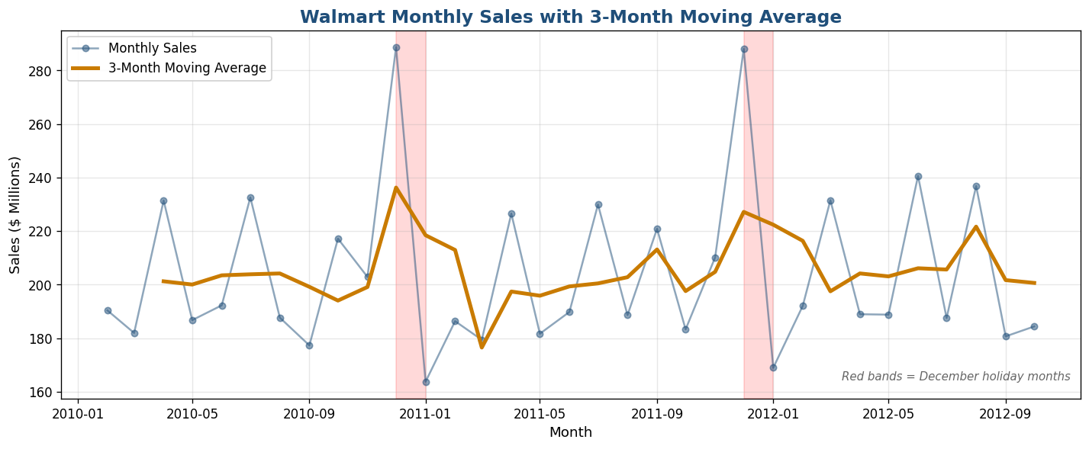
Figure 1 — Monthly sales (blue dots) with 3-month moving average overlay (orange line). Red bands mark December holiday months. The MA reveals a modest underlying upward trend hidden beneath the holiday noise.

Trend test
Statistic | Value | Interpretation
MA3 linear slope | +$208,891 / month | Modest growth
Implied annual growth | ~$2.5M / year | Slight upward drift
Trend direction | UPWARD | Sales growing slowly
Caveat: 2012 data ends in October, so the 2012 holiday spike is missing from the series. The most recent MA3 values are temporarily depressed for this reason — not because of a true business decline.

Question 4 — Holt-Winters Exponential Smoothing Forecast

Why exponential smoothing beats a simple average
- Captures trend: sales are not flat — they grow modestly. A simple average ignores direction.
- Captures seasonality: Walmart sales have a powerful 52-week annual cycle (holiday surge, summer dip, back-to-school bump). A simple average flattens these patterns into a meaningless mean.
- Weights recent data more heavily: exponential decay means last month's data influences the forecast more than data from 2 years ago — appropriate for a business that evolves over time.

Model specification
Python — Holt-Winters
model = ExponentialSmoothing(
weekly_sales,
trend='add', # additive linear trend
seasonal='add', # additive seasonal component
seasonal_periods=52 # 52 weeks per annual cycle
)
fit = model.fit()
forecast = fit.forecast(12) # 12 weeks ahead = ~3 months
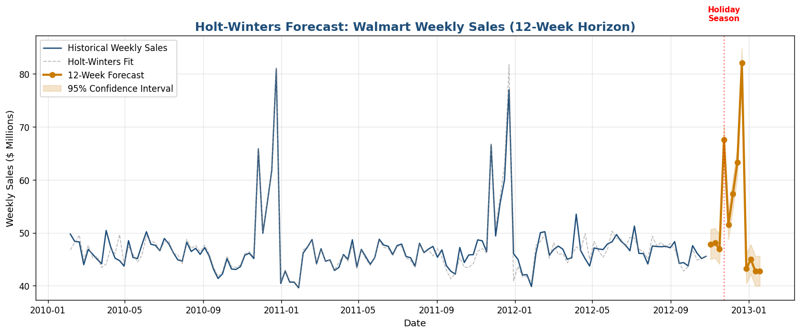
Figure 2 — Holt-Winters forecast with 95% confidence band. The model successfully reproduces both the underlying weekly baseline (~$46M) and the holiday spike pattern. The forecast for late Nov–Dec 2012 shows the expected seasonal surge.

Key forecast figures
Metric | Value
Forecast window | Nov 2 2012 – Jan 18 2013 (12 weeks)
Forecast mean per week | $53.2M
Last 12 weeks of actuals (mean) | $46.2M
Holiday week peak (Dec 21) | $82.1M
Off-season weeks (Jan) | ~$43M

Question 5 — Holiday Season 2012 Forecast with 95% CI

Approach
Use the Holt-Winters model from Q4 to project total sales across the 6-week 2012 holiday window (Nov 23 – Dec 28), then quantify uncertainty with a 95% confidence interval. Compare to the actual 2010 and 2011 holiday season totals to assess directional change.

Historical context
Holiday season | Total sales (6 weeks) | YoY Change
2010 (actual) | $399,707,120 | —
2011 (actual) | $401,110,688 | +0.35%
2012 (forecast) | $364,994,062 | −9.00%

95% Confidence Interval
Quantity | Value
Per-week residual sigma (σ) | $1,444,221
6-week sum margin (z=1.96) | ±$6,933,704
Forecast holiday 2012 | $364,994,062
95% CI lower bound | $358,060,359
95% CI upper bound | $371,927,766
COO Action — Plan for a Softer Holiday
Forecast shows a 9% YoY decline in holiday sales (vs 2011 actuals). The 95% CI is narrow (±$7M on a $365M forecast) because two prior holiday seasons of training data give the model strong confidence in the seasonal pattern. Brief liquidity planning teams to budget for lower holiday cash inflows. Inventory orders should be sized to the forecast, not to last year's actuals — over-ordering risks meaningful post-holiday markdown losses.

Question 7 — Operational Liquidity Proxies

Why proxies?
Walmart's balance sheet (current assets, current liabilities, inventory, cash) is not in this dataset, so traditional Current Ratio and Quick Ratio cannot be computed. We instead derive two operational proxies for the firm's ability to absorb a sudden demand shock.

(a) Sales Velocity Ratio = avg Weekly_Sales ÷ Store Size
Higher velocity means more revenue extracted per unit of footprint — better operational leverage in a downturn. Computed per store, then averaged by store type.
Store Type | Stores | Avg Size (sqft) | Avg Weekly $/sqft
A (largest) | 22 | 177,247 | $0.115
B (mid-size) | 17 | 101,191 | $0.124
C (smallest) | 6 | 40,541 | $0.236

(b) Holiday Sales Buffer = (holiday avg − non-holiday avg) ÷ non-holiday avg
Higher buffer means greater dependence on holiday quarter cash inflows — more vulnerable to a weak holiday season.
Store Type | Non-Holiday Avg | Holiday Avg | Buffer %
A | $20,099 | $21,659 | +7.76%
B | $12,237 | $13,156 | +7.51%
C | $9,519 | $9,983 | +4.87%
ALL | $15,901 | $17,036 | +7.13%
Cash Crunch Readiness — Type A is Most Vulnerable
Type A stores combine the LOWEST sales velocity ($0.115/sqft) with the HIGHEST holiday dependence (+7.76% buffer). They generate less revenue per square foot during normal weeks AND rely most heavily on the holiday surge to make up the gap. The board should consider establishing a credit facility sized to bridge a 4-6 week cash gap if holiday sales miss forecast — particularly important given the −9% holiday forecast from Q5.

Question 12 — Sales-Per-Square-Foot Efficiency + Improvement Plan

Calculation
Sales per Square Foot per Week = (total store sales ÷ number of weeks) ÷ store size. Higher means more revenue extracted per unit of footprint — the universal retail efficiency benchmark used by Walmart, Target, Costco, and most sell-side analysts.
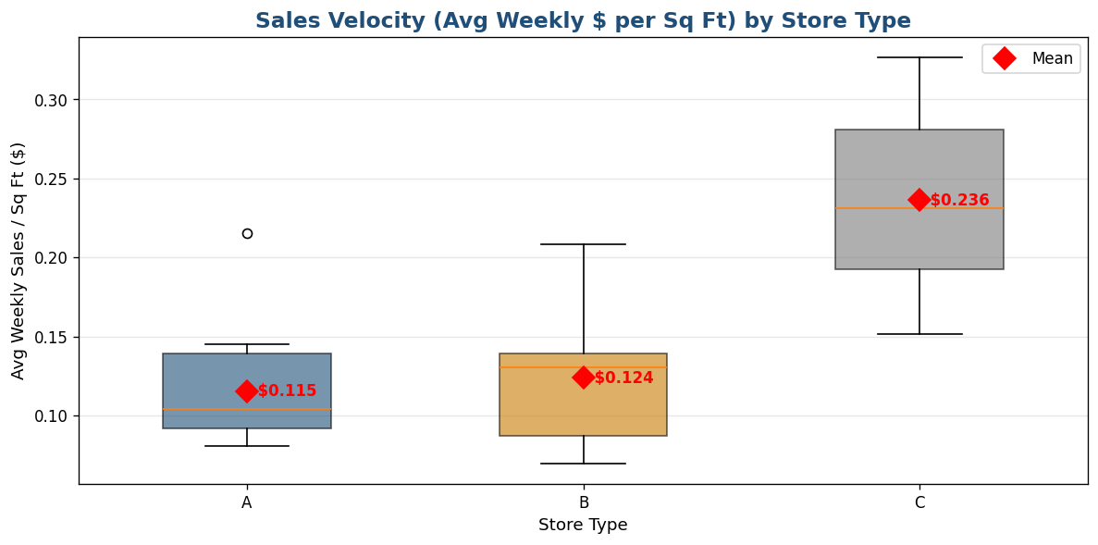
Figure 3 — Sales velocity by store type (box plot with mean diamonds). Type C stores generate twice the revenue per square foot of Type A or B — a striking finding given Type A stores are the largest format.

Result
Store Type | Stores | Avg Size (sqft) | Avg Weekly $/sqft
A | 22 | 177,247 | $0.1154
B | 17 | 101,191 | $0.1238
C | 6 | 40,541 | $0.2364

Recommendation: department-mix transplant for Type A stores
Type A is the weakest performer per square foot. A 2% improvement target (to $0.1177/sqft/week) is conservative and achievable through a single operational change: replace bottom-quartile-performing departments in Type A stores with the higher-velocity department mix already proven in Type C stores.
Metric | Value
Current Type A efficiency | $0.1154/sqft/week
+2% target | $0.1177/sqft/week
Implied uplift per Type A store (annual) | ~$22,700
Across all 22 Type A stores | ~$500,000 / year
Why This Works
It's a re-allocation of existing shelf space, not new capex or additional markdown spend. The data already proves Type C department mixes earn more per sqft — bringing those mixes into Type A is a low-risk transplant. Pilot in 3 Type A stores for one quarter, measure delta vs control, then scale to all 22 if results validate the projection.

Summary of Findings
Q | Topic | Key Result
1 | YoY sales vs fuel cost | Sales −3.18% while fuel +26.14% — margin compression
2 | MarkDown common-size | Total promo = 2.97% of sales; MD1 dominates at 1.16%
3 | 3-month moving average | Modest upward trend (+$209K/month); holiday spikes captured
4 | Holt-Winters forecast | 12-week forecast captures holiday surge; mean $53M/wk
5 | Holiday 2012 forecast | $365M (95% CI: $358M-$372M); −9% YoY vs 2011
7 | Liquidity proxies | Type C most efficient/sqft; Type A most holiday-dependent
12 | Sales-per-sqft | Type A weakest; +2% mix optimization → ~$500K/yr uplift

Pyramid Recommendations to the COO
- 1. Fuel cost audit (URGENT) — Q1 shows fuel rising 8× faster than sales declined. Commission a logistics route optimization and supplier renegotiation review within the current quarter.
- 2. Holiday inventory recalibration — Q5 forecasts a 9% YoY decline in holiday sales. Adjust inventory orders to the forecast, not last year's actuals.
- 3. MarkDown rebalancing test — Q2 shows MarkDown1 consumes 4× more revenue than MarkDown3. Run an A/B test on rebalancing $5M from MD1 to MD3 next fiscal year.
- 4. Type A department-mix transplant — Q12 quantifies a $500K/year revenue uplift from bringing Type C department mixes into Type A stores. Pilot in 3 stores for one quarter.

